Thomas Jubb

MMA League Table
Computer Science NEA

Contents
Desk-based research 2
Stakeholders 7
Investigation Method 1 8
Investigation Method 2 9
Investigation Method 3 11
Document Collection 14
Processing 18
Limitations 20
Working specification 21
Justifications of the methods to be used. 22
Objectives and success criteria 22

Desk-based research
  - Example 1 – Tapology
Tapology is an MMA website which shows rankings, news and upcoming fights.
- The page shows which fights are about to happen, and how it also lets you enter a prediction.
- When the page shows what fights are about to happen, it also has two pictures of each of the fighters that will be fighting in the bout and their names.
- You can also search for individual fighters, bouts and events.
- The Tapology system shows the main pages of the website on top.
- In the rankings page, at the top, you are given the option to sort the rankings by 4 broad categories.
- The rankings page shows the major trending changes to the rankings at the top and shows a graph of the rankings change for all the fighters
- Below that, it shows the ranking changes to all the elite fighters.
- The website also shows the top 50 ranking changes in a table form
- The website shows individual ranking boards in a large table format
- The table has the ranking first, then a picture of the fighter. It then shows information about the fighter, and then their record, finally.
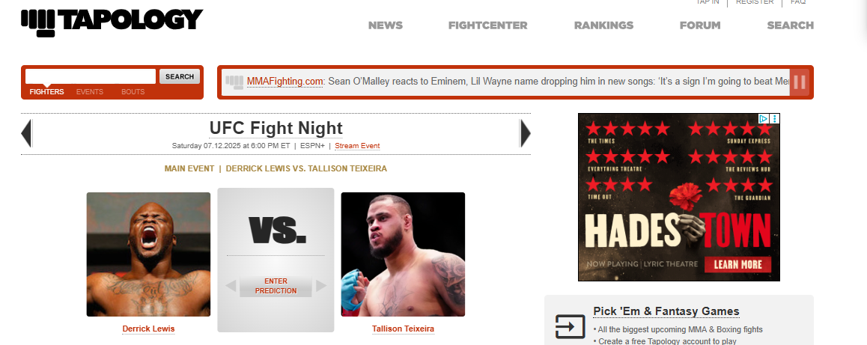
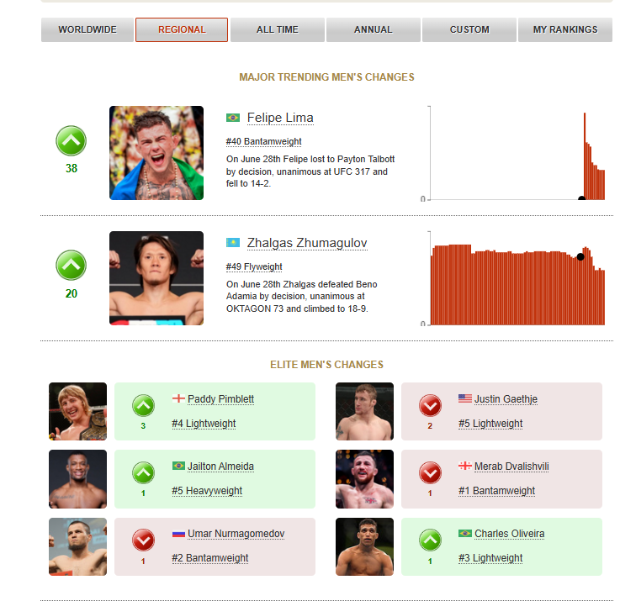
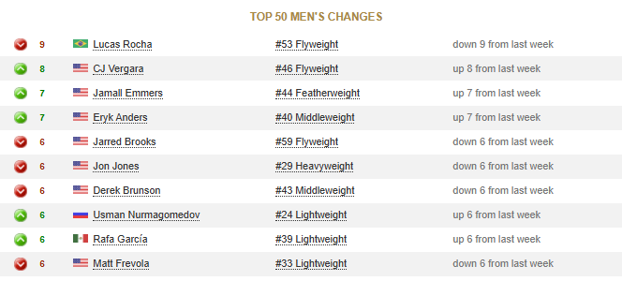
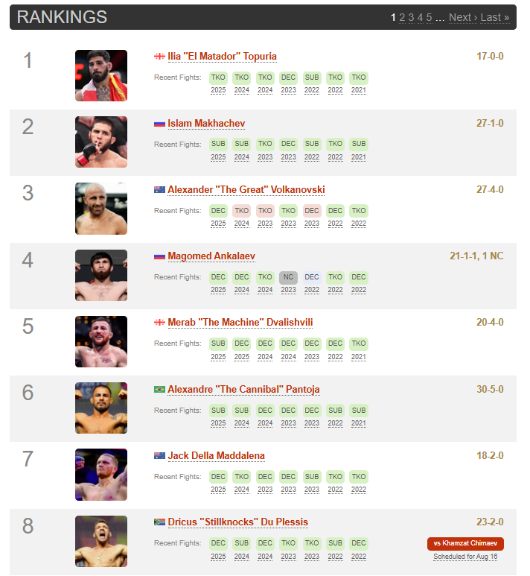

My Takeaways
- I like the idea of being able to see the ranking changes of the elite fighters first, as they have the most impact, so in my system, I would probably just take away the trending rank changes part and just have the elite.
- I like the colour scheme because it’s easy to read and take in quickly, so I will adapt something like that into my project, such as a higher contrast two-tone scheme.
- I like the use of a table to show ranking changes, and I think I could make this look good in my project in a SQL table
- I like how you can enter the prediction for the fights that are about to happen. In my project, I could add to this by also adding the ability to vote on the entertainment of a fight.
- I like how you can gauge the fighters at the event by seeing a photo of them both. I think that it would make it easier to see what kind of fight you’re getting by adding more information about both fighters. Main things would be rankings and records, but I could also add things like the odds.
- I think that it’s a good idea to include the ability to search for individual fighters if you want to look at their stats. I don’t really think that adding the bouts is necessary, as you’ll see that information on the fighter’s page anyway. Also, the system I’m making is focused on the fighters themselves, so I don’t really think that I need the information about an event, either, meaning that I will add these
- I personally like this way of showing rankings in a large table format a lot. I think the large table format makes all the information stored way easier to digest.
- I may be limited in the way I can display lots of images at the same time from the SQL database
- I like the little flag which tells you which fighter is from which country.
- I don’t like the order of the table. In my opinion, the name should be first, so you can read the names of each number ranking quicker, instead of having the picture of the fighter

  - Example 2 – UFC Official Website
- The front page of the UFC website shows every ranking with the champion’s image at the top of each weight class ranking
- If you aren’t the champion, the chart only shows your rank, name and rank change.
- For each fighter, it shows a picture of them, their division, their record, their win streak, the ways they’ve won their previous fights and their upcoming and last fights.
- It also shows tags which tell you other info, like if the fighter is a champion, if they’re active
- Under that part, it shows 7 different boxes, which show different stats
- These stats come with charts a couple of times. For this example, there are two pie charts and heatmaps based on significant strikes
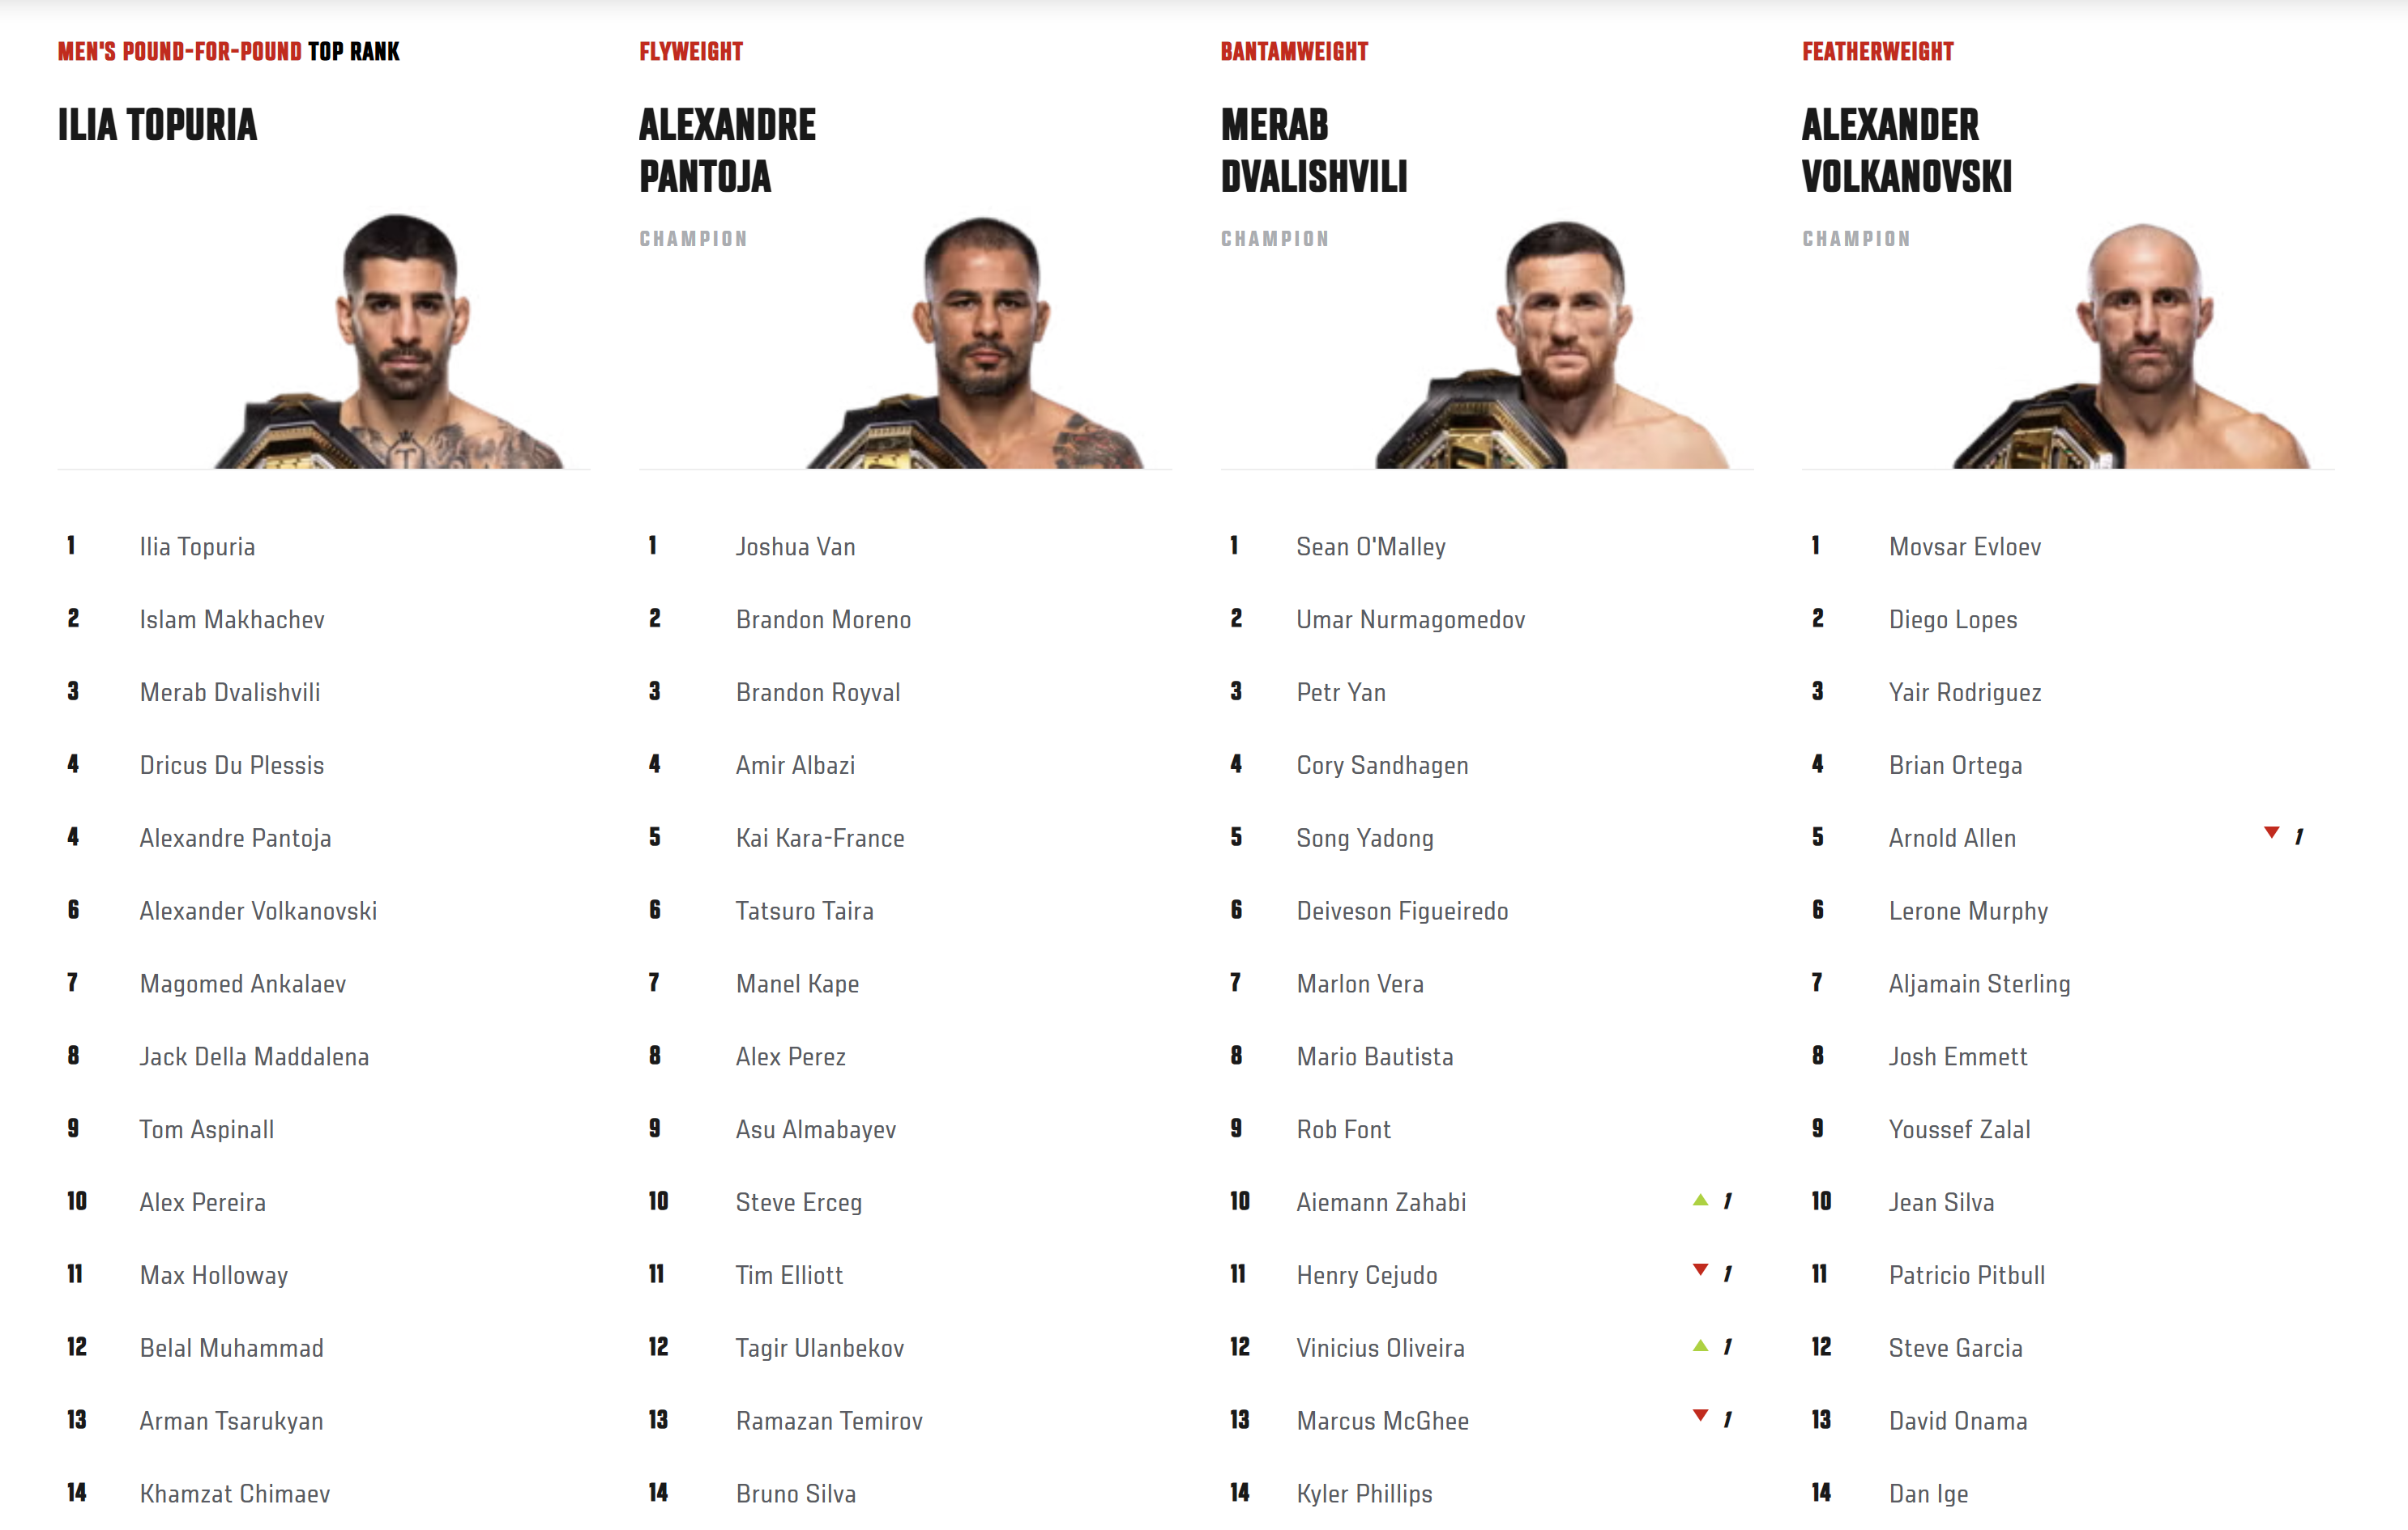
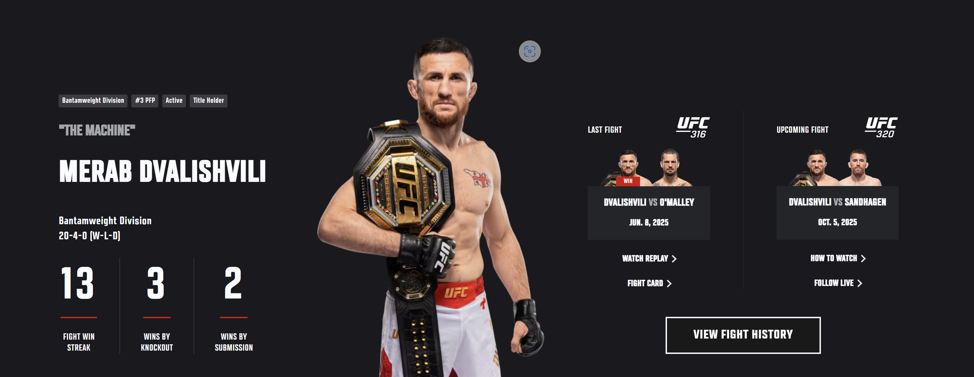
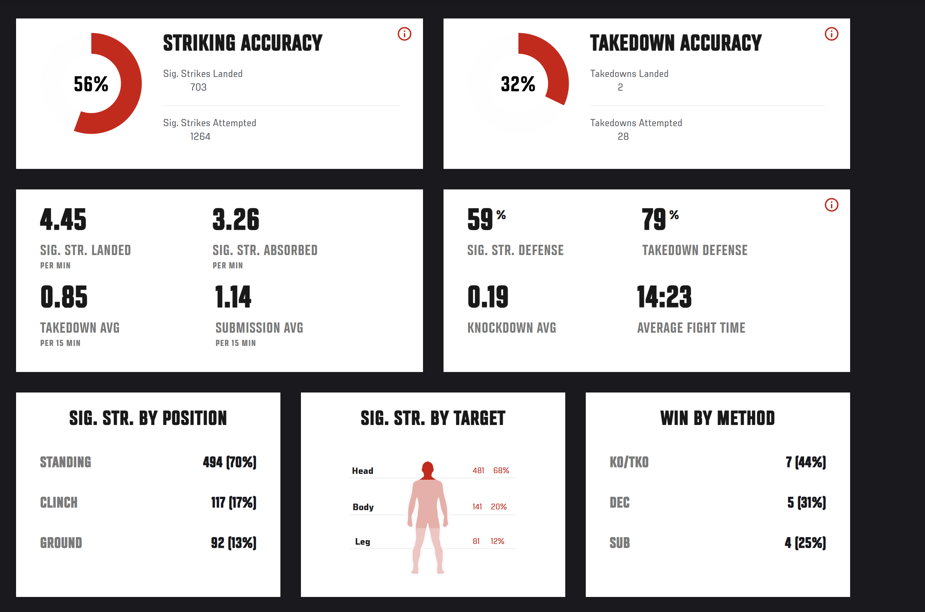

My takeaways
- I like how the front page shows all the rankings so compactly, but, in my opinion, they don’t show enough information. I will have to find a balance between something like this and a UI that’s too cluttered.
- I like the tag system; I can integrate this into SQL on fighter profiles.
- I like how the number of tables is more diverse than just having pie charts. In my project, I want to have a few more ways of showing the data to make the end user experience more interesting
Example 3 – FightMatrix
- The table is very simplistic and efficient
- It is limited in what it shows compared to the others
- The points it shows are fighter scores calculated using predictive data and past data
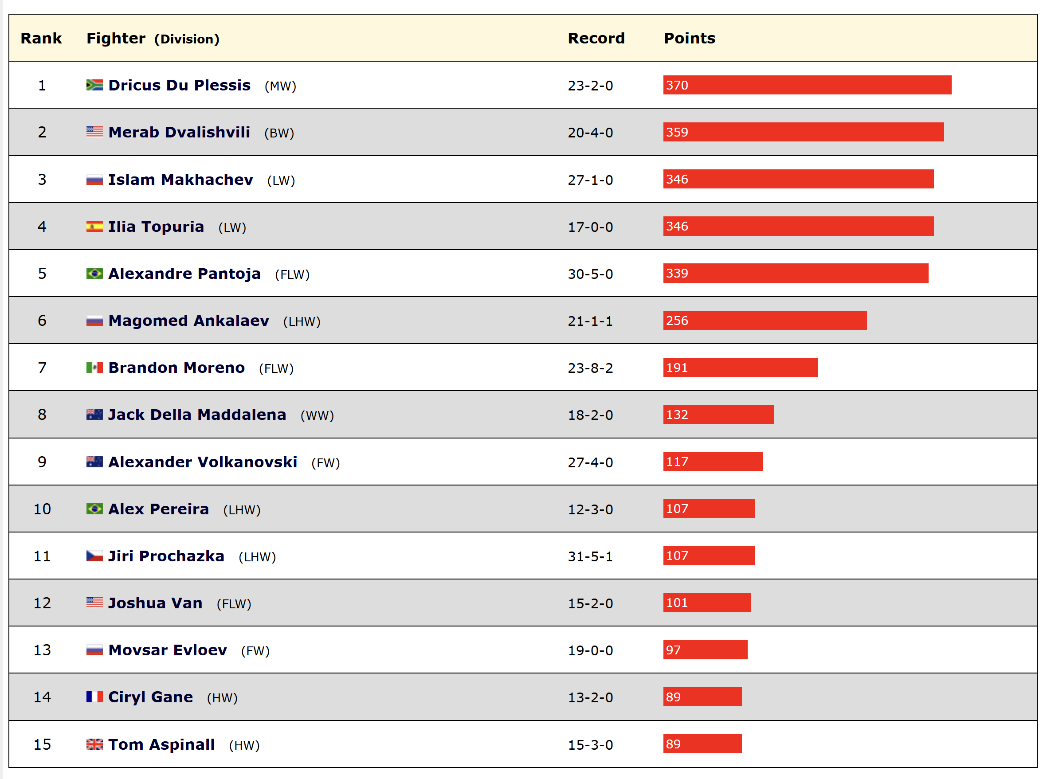

My Takeaways
- I like how simplistic the table is, as it lets you take in the essential information quickly
- I don’t like how it doesn’t show who the champion is because that is very important contextually to someone’s ranking
- I don’t think that it’s necessary to show the point system directly to the user. I think that the ranking tells the user enough, and it takes up space where more important information can be.

Stakeholders
Fans
MMA Fans are the end-users who will look at the rankings and stats. They will also send requests to generate odds for fights. The fans are going to want a high-quality interface that is easy to use and visually pleasing. They are going to want quick access to specific fighter statistics to see a good enough picture in a short amount of time when they research a fighter. They want up-to-date and accurate statistics for fighters. Also, they want odds for fights that are as accurate as possible. They will also want extra features like voting predictions for fights, for example. I could collect this info by doing surveys of MMA fans to see what they would like out of an MMA system.
Fighters
MMA Fighters won’t probably use the system directly, but they will want to have an accurate representation of the system out of fairness, meaning that they will want accurate rankings and accurate odds. The way I can meet the needs of fighters and appease them is by doing good research into odds, so I can find out the most accurate type, and making sure that the system I use to rank the fighters takes a lot of data into account and takes the data into account proportionately.

System Admins
The admins of a system are the ones who put the data into the system and host the server that the end-users access to see the fighter data. Like the end-users, they will want an easy-to-use and aesthetically pleasing interface for their part of the system, but they will also want the system to be efficient and reliable storage-wise. They will also want good features that can attract more users. I could get this data by interviewing an admin of an already existing MMA system to see what they like about the system.
Promoters
MMA Promoters are the people who usually run the championship or league that an MMA fighter will fight in. They will be the people who get the System Admins to run the system to show fighter data. They will want the end-user (MMA Fans) to have a good experience. This means up-to-date and accurate data and an easy-to-use interface. A promoter would also value things that make a fighter/bout look better or more entertaining, as this makes the event of an MMA fan paying for PPV or a ticket for an event a lot more likely to happen.

Investigation Method 1
I am researching MMA fans as they are the main users of my system. My goal for this part is to figure out what stats and features I can put into the frontend of the system to make it as user-friendly as possible. I chose to gather this data by using a questionnaire, as this is the most efficient way to get data from many people.
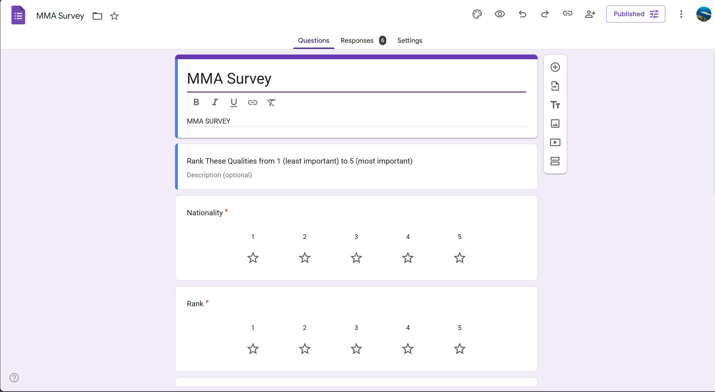
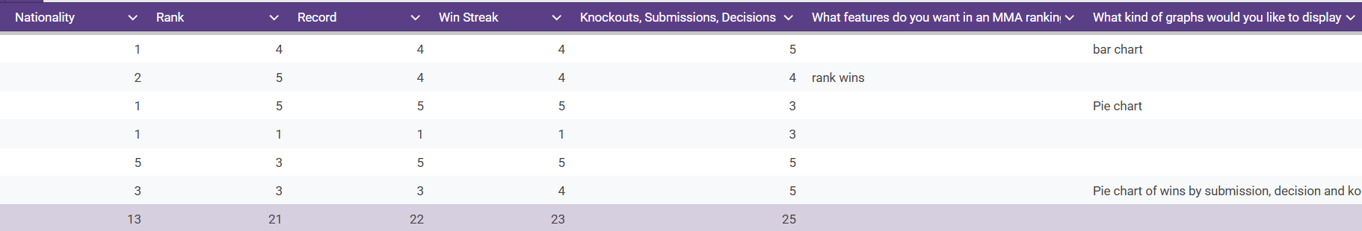
What I have found from this method is that people don’t really care about nationality and care more about how many knockouts, submissions, and decisions someone has. I think I could put losses on there, which would encompass a big record. I like the pie chart idea and the ranked wins idea.

Investigation Method 2
For my second investigation method, I will research system administrators, as they will inform me about the key requirements for the administrative side of the program, such as reliable and efficient data entry, and ease of use when inputting data into the system. I will conduct this by emailing the administrators of larger MMA statistics websites.
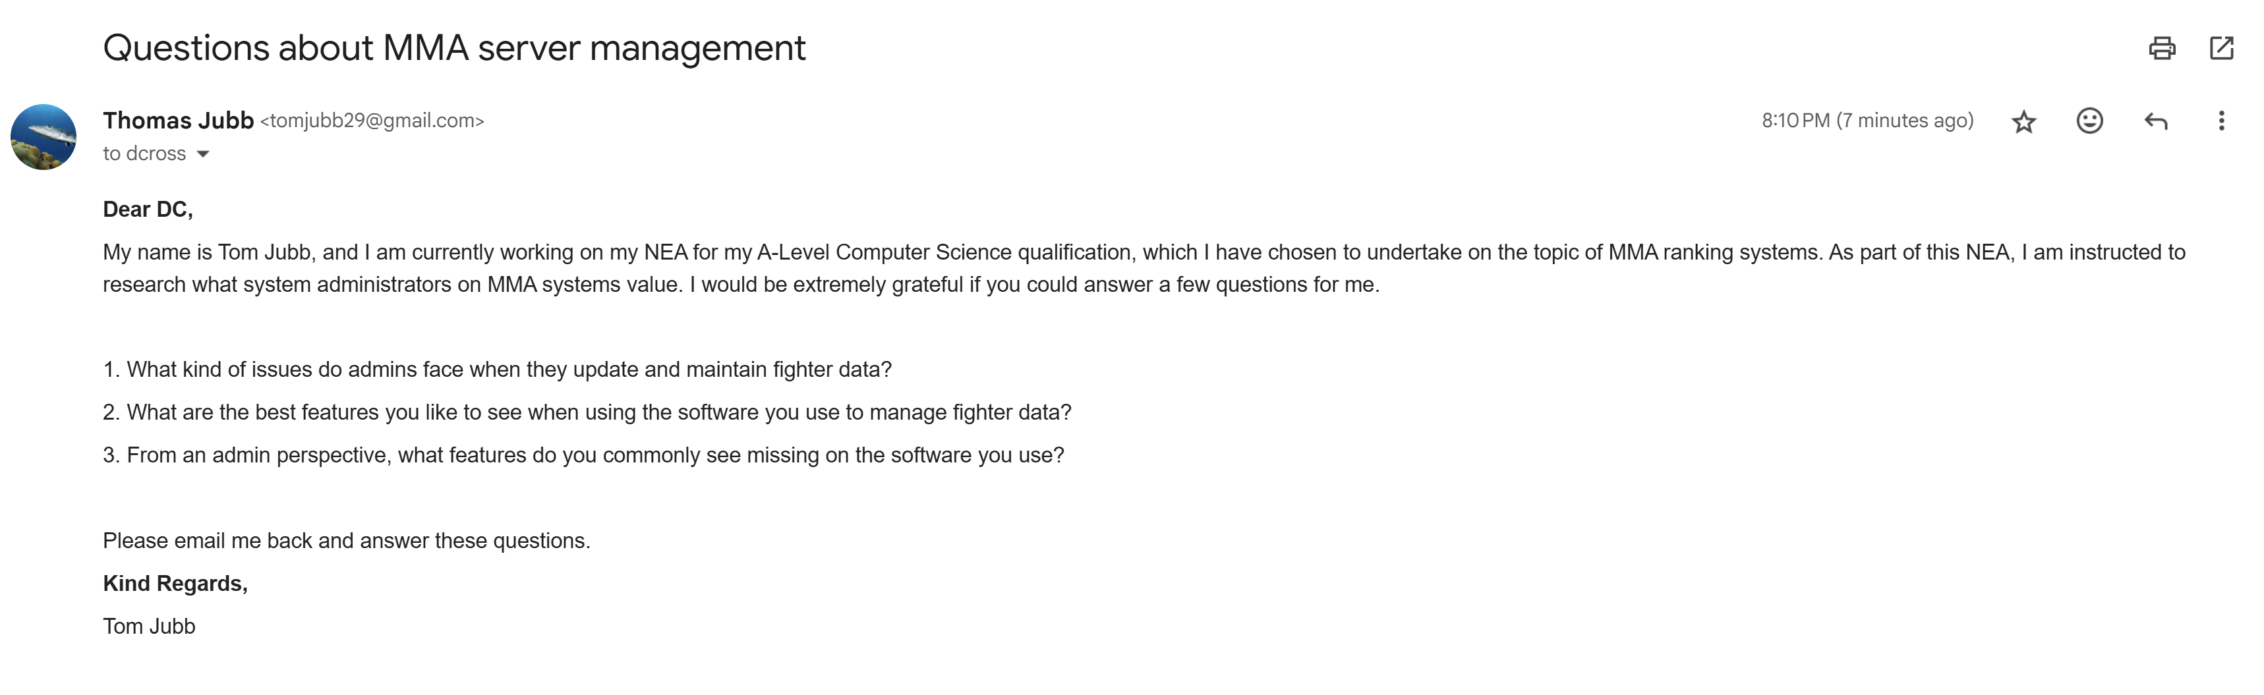
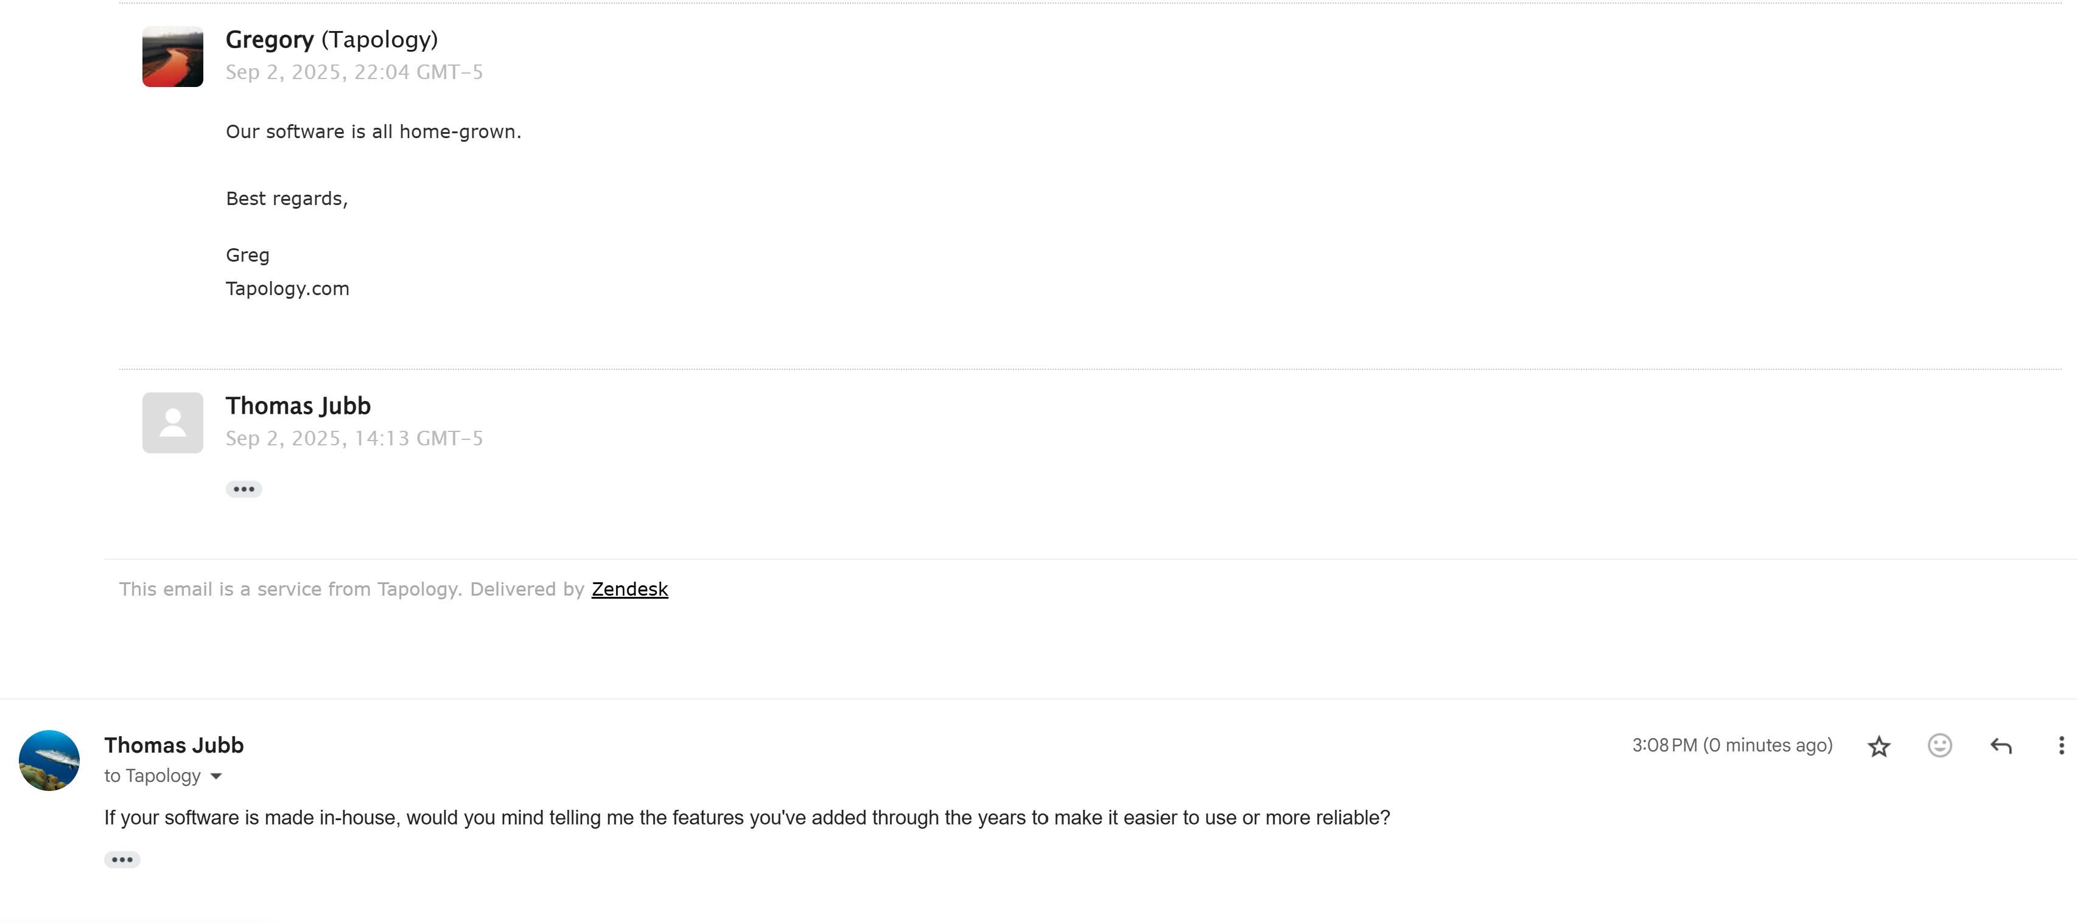

Since I have received no response from any MMA website admin, I will find Q&As online from these admins, which will have the same effect.
From what I have found, Tapology places a high value on user data validation, which can sometimes lead to frustration for organisations that submit their data to their website. However, they still have things like misspelling errors in their data. What this research has revealed to me most is a gap in user-to-admin input and communication on MMA stats websites, which underscores the need for a user voting system and a more user-oriented program.

Investigation Method 3
For my third method of investigation, I want to find out more about MMA fans and how they navigate MMA websites. I can do this by observing MMA fans using an MMA website. This will tell me what people like and don’t like about MMA sites in practice, what pages of the website people are most likely to look at, and what data people are most likely to find interesting.
The fan I chose first had a look at the featured fight and then looked at the individual stats of a fighter (Diego Lopez). He looked at Lopez’s fighting history and upcoming fights, and from there, he looked at his upcoming opponent, who is Jean Silva. From there, he looked at the info on Jean Silva’s previous fight against Bryce Mitchell. After that, he clicked the website’s logo to go back to the homepage. After this, he searched for another fighter (Jon Jones), but he encountered an issue with the search because it brought him a fighter who wasn’t Jon Jones.
From this observation, I have learned that MMA fans tend to go for events first and then view the context of the fight by seeing the fighters that are fighting. They also do this in reverse by looking at a fighter’s fight history. They also tend to view fighter information more than fights themselves.
Because of this research, I am going to make navigation between fights as easy as possible and make sure the UI is fighter-focused. I also need to make sure that the search system is robust to stop errors like what happened with Jon Jones.
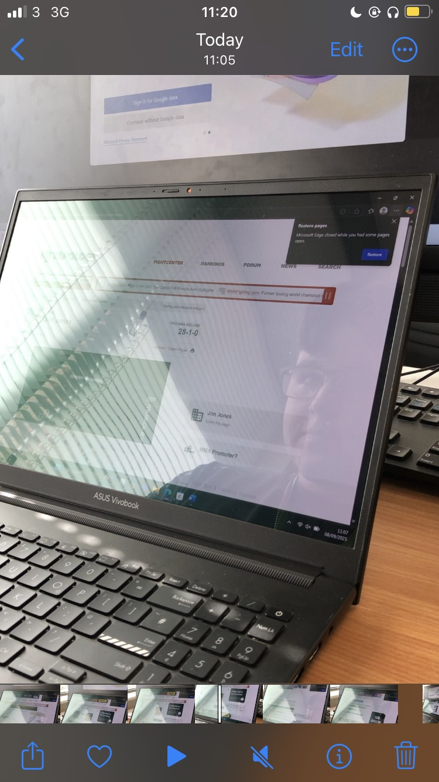

Document Collection
Glicko 2
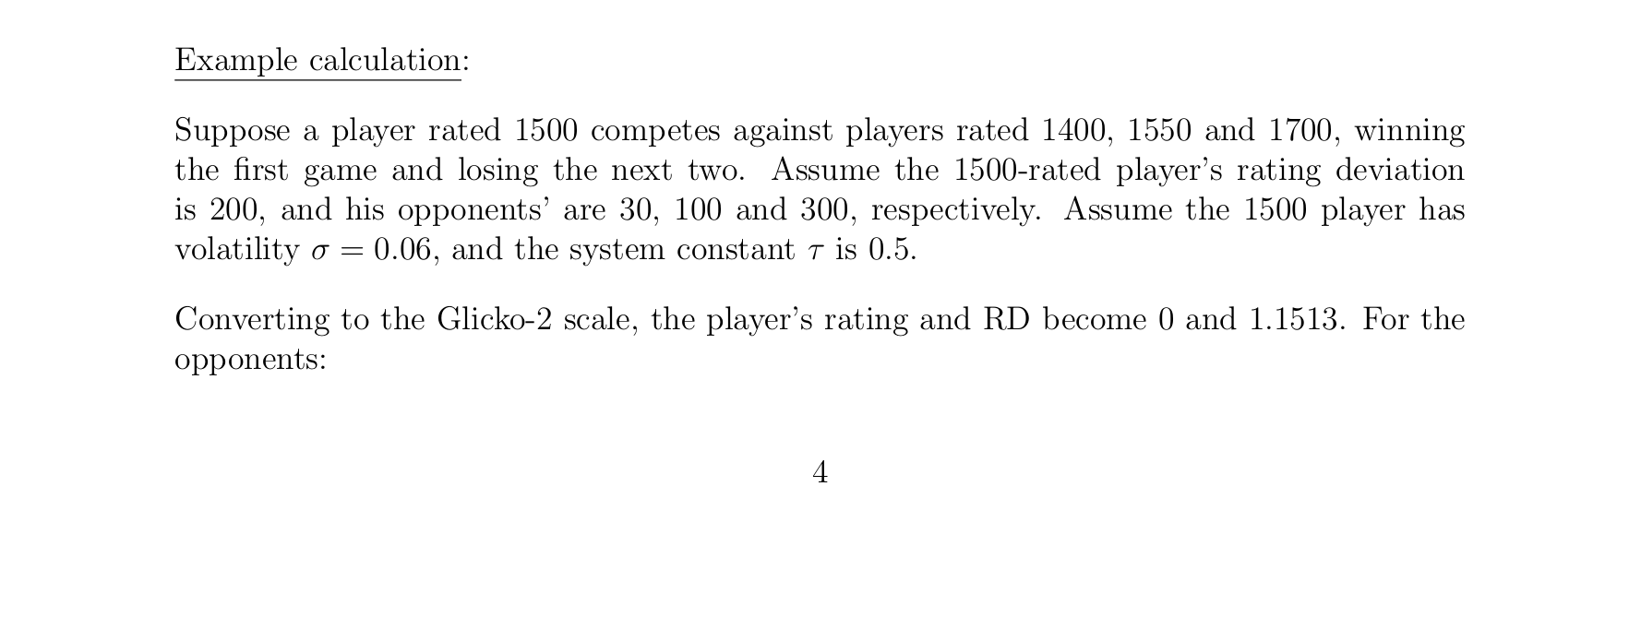
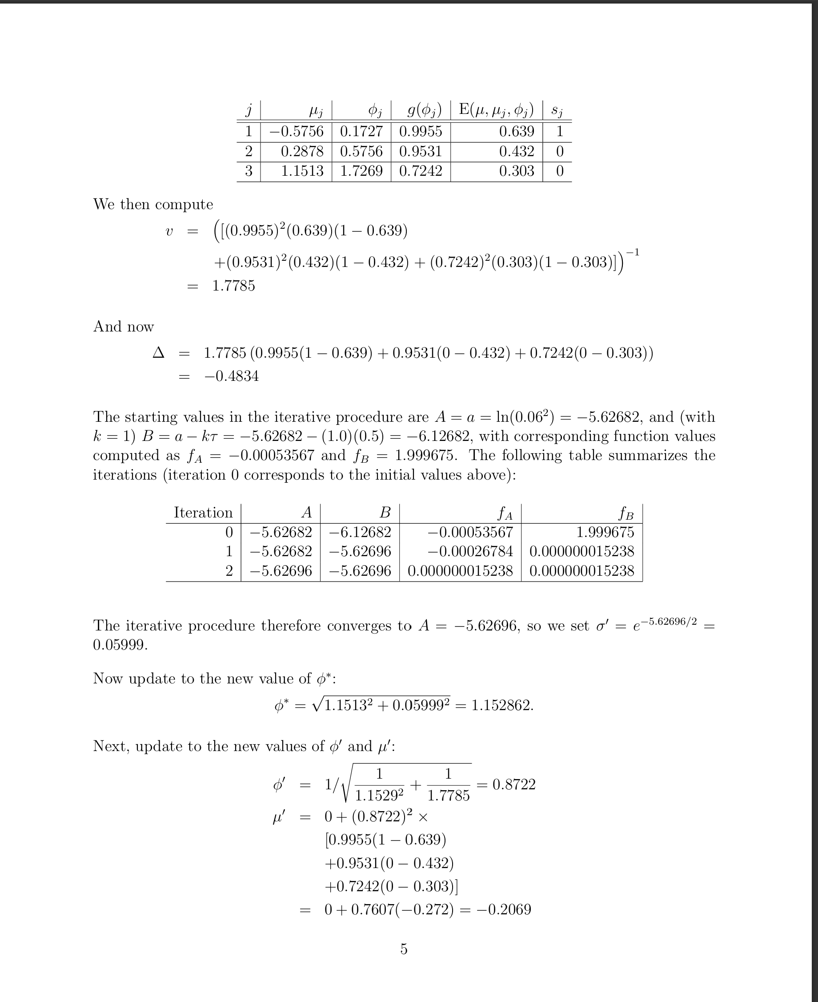

Bradley-Terry Model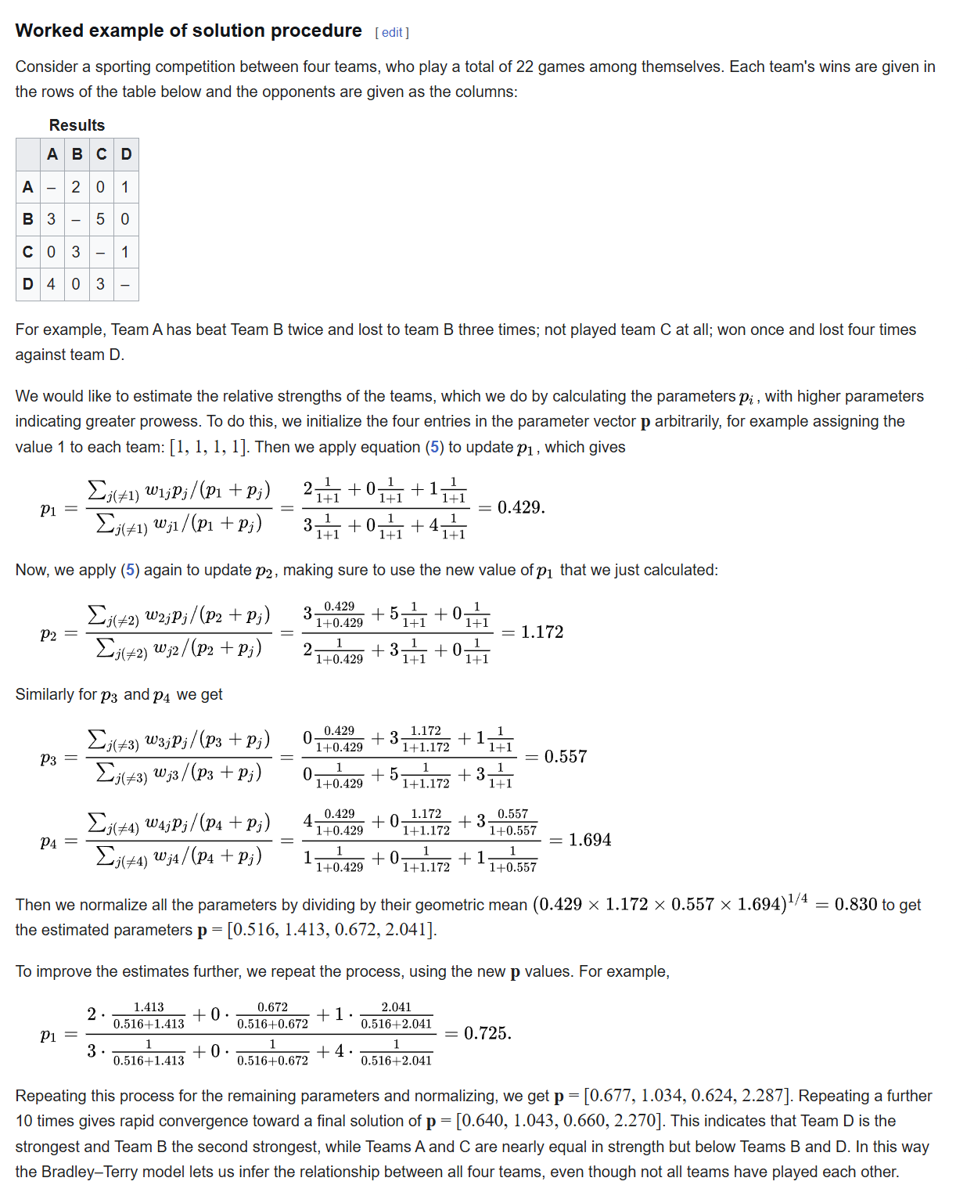

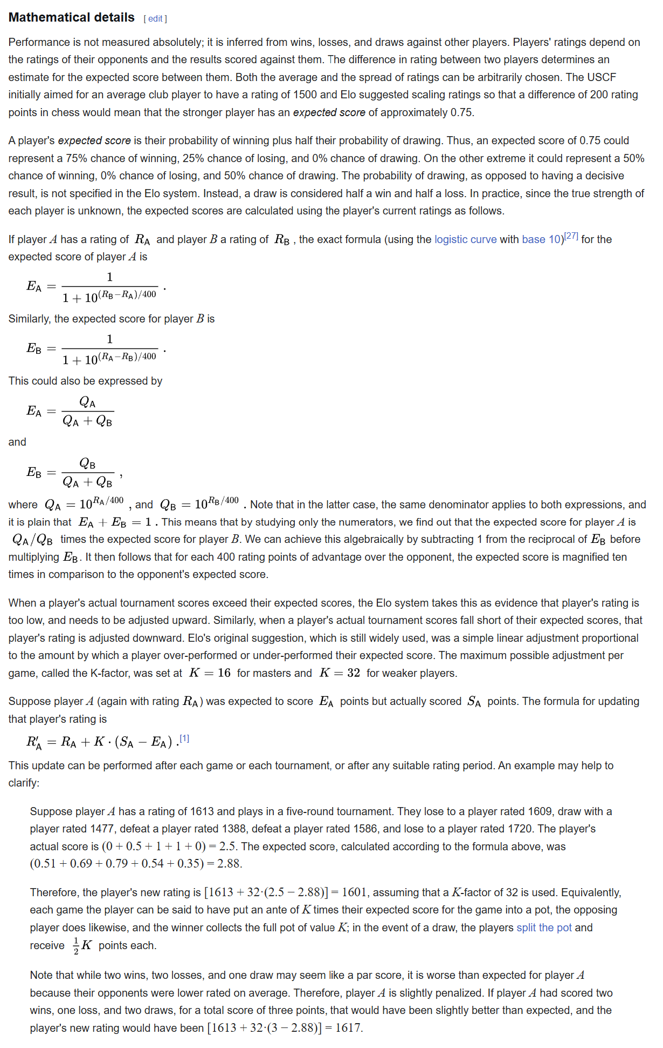Elo Model

Processing

Odds Calculation Example – Elo System
- Made for chess, which, in my opinion, has many similarities to MMA as both are tactical, head-to-head, competitive sports. However, it is also a downside because chess can get away with having a player’s experience as the main factor in a rating system, because ageing doesn’t matter as much in chess as it does in MMA
- Having a predicted outcome is already integrated into the formula, which makes it simpler to make a prediction
- It is a good balance between being mathematically fair but still being rewarding to underdogs if they manage to get an upset win
- Rating changes also rely on a K-Constant to determine how big the rating change is going to be, which will mean that I will have to make a separate algorithm to determine how much a fight matters
Odds Calculation Example 2 – Glicko 2 System
- An evolution of the Glicko system, which is an evolution of the Elo system.
- Instead of relying on a K constant, Glicko 2 looks at a competitor’s reliability and activity, which means that you get a more accurate model, but it still doesn’t take fighter deterioration into account
- Can be computationally expensive to estimate a whole promotion’s scores, but I don’t think it will matter too much, as you won’t have to generate the scores every time you open the program.
Odds Calculation Example 3 – Bradley-Terry Model
- Calculates the probability of a fight proportionally by the strength of each fighter, which is calculated from the fighter's past fights
- It is good for incomplete data, which is good for smaller championships
- It is easier to implement
- Only takes strength into account and no other things like Glicko 2
Data Collection Example - UFC API
- Python-based, which makes integration easier
- Easy to use, which means it will be simple to integrate this into my program
- Data may be incomplete, which is bad when we need a lot of data to calculate odds
- Little to no documentation, which means that if I have an issue, I am practically on my own

UI Example – Flask
- Is lightweight, which is better for all parties
- Works well with SQL, meaning I can integrate the database more easily.
- Works well with other Python libraries, meaning the analytics is easier to integrate
- It is easy to access for the end-user, no downloads needed if hosted on a web server; however, this also means that if I don’t use a web server, Flask doesn’t work out of the box.

UI Example – QT Designer
- It is very customisable, meaning that I can deploy the customisation ideas I discussed earlier more easily.
- Produce a more cross-platform desktop interface, meaning it’s easier to deploy out of the box
- Has a lot of embedding support for things like graphs and SQL

Limitations
- Rankings take about 48 hours to update. This leaves fans waiting to see the impact of fights, which can be past some people’s attention spans, and puts less on the table for the fighters as they won’t really see the effects on the system for 48 hours.
- Some systems are cluttered with information that doesn’t really matter to the casual viewer, and then also go and not show enough context, like who is a champion or not.
- Smaller promotions don’t even have proper records, meaning that if you are a smaller fighter, you aren’t represented.
- A lot of MMA websites don’t let you filter enough data, meaning that you can’t find the records you really want to find.
- A limitation that the current systems have is that they rely too much on humans, and that creates bias. The way the system in the UFC works is that 20 sports media people do a vote over the rankings. Not only does this system create bias, but it also could lead to corruption and inconsistencies in data.
- Searching can be inaccurate on some MMA websites.
- A lot of MMA websites don’t value user input.

Working specification
I am going to make an MMA program with two sides. The main side will be the user side, where there will be a league table with individual fighter stats, such as nationality and record. You will be able to search for fighters based on these factors. Each fighter will have their own page, which shows their record, fight stats such as submissions and knockouts, fight history and upcoming bouts. The program will also feature an odds calculator, which will use a combination of the Glicko 2 model and the Bradley-Terry model to calculate odds. The program will also feature an entertainment predictor. The way this will work is by taking a short survey at the beginning, which will determine what the user likes or not. From this survey, the system will determine how entertaining a fight will be for you. Users will also be able to vote on fights based on entertainment.
On the admin side, you will be able to input data about fighters and fights manually through a simple interface. However, you will be able to use a UFC scraper as well.
The database will be on SQL, and the UI will use QT with a high contrast palette and simplistic visuals. The system will be heavy with visuals, with graphs such as heat maps and pie charts to show analytics about fighters.

Justifications of the methods to be used.

Firstly, for the UI, I think I will use QT Designer. I am doing this because I like how it integrates with other Python packages, and it removes an extra layer of processing that you would get with Flask, as you need to consider more server communication. This means I can allocate more resources to processing. It also means that when you get the Python programme, it works straight away, whereas with a serverless Flask approach, the user would need to worry about more things, which isn’t ideal, especially if the MMA fan doesn’t have much technical knowledge.
I am going to try out the UFC API with my prototype for data scraping because it seems to be the simplest way to get the job done and the best one to integrate with my SQL databases due to it being in Python, which is the primary language I am using to develop this program.
For my odds calculation. I think I am going to try to combine the Bradley-Terry model and the Glicko 2 model. That way, I can account for the lack of data, but I can add more accuracy if there is more data.

Objectives and success criteria

- The system will generate a ranked leaderboard of fighters based on the database it’s given
- The leaderboard will display the fighter's name, record, nationality, weight class and methods of winning
- The table will be sortable by weight class, nationality, and the belts they’ve held
- You will be able to search for a fighter's name and see their page
- The fighter profile will feature past fight history, upcoming fights, statistics (wins/losses by KO, submission, decision), belts, and ranking using graphs like heat maps and pie charts
- The system must take an input of two fighters and give the odds of either of them winning by using a combination of the Glicko-2 model and the Bradley-Terry model.
- Upon first use, the system must prompt the user to make a profile so they can answer a short survey about what they find entertaining about an MMA fight. Using this, the system will be able to show how entertaining a fight is going to be to you based on what you like
- Users will also be able to vote on how entertaining a fight is going to be
- Admins will be able to manually input fighters and fights
- Admins will also have the option to use a UFC scraper.
- The system will validate inputs by rejecting duplicate data and incorrectly formatted records
- The system will use an SQL database to store data
- Rankings need to update when you enter fight results automatically
- The UI needs to be implemented with QT designer
- The user needs to be able to navigate between the league table, fighter profiles, and the odds calculator in as short a time as possible.
- The system will take a survey from the user at the beginning and make a profile that says what they find entertaining and not
- Users will be able to vote on fighters and give them a percentage approval rating
- The system will give each fighter a score according to the fighter’s info to determine how entertaining the user will find the fighter.

